|  |
| --- |
| Anvil v1.1 |
| User manual: Company Admin |
| User documentation for the Anvil task management system. |



|  |  |  |
| --- | --- | --- |
| |  |  | | --- | --- | | |  | | --- | | Anvil is proudly brought to you by www.butternet.com  Butternet_1.png | | |

Table of Contents

[Introduction to Anvil 1](#_Toc293150365)

[Registering your company 3](#_Toc293150366)

[Managing your company’s projects 4](#_Toc293150367)

[Project management 4](#_Toc293150368)

[Adding/Editing a Project 4](#_Toc293150369)

[Deleting Project 5](#_Toc293150370)

[Project backlog 5](#_Toc293150371)

[Manging releases 6](#_Toc293150372)

[Adding/Editing features 6](#_Toc293150373)

[Managing tasks for a feature 7](#_Toc293150374)

[Managing your companies users 8](#_Toc293150375)

[Adding a user to your company 8](#_Toc293150376)

[Managing teams inside your company 8](#_Toc293150377)

[Using the taskboard 10](#_Toc293150378)

[Selecting Project and release 10](#_Toc293150379)

[Drag and dropping tasks 11](#_Toc293150380)

[Adding a task 11](#_Toc293150381)

[Logout and Edit Details 11](#_Toc293150382)

[Managing impediments 12](#_Toc293150383)

[Using Anvil Support 13](#_Toc293150384)

[User documentation 13](#_Toc293150385)

[Logging a ticket 13](#_Toc293150386)

# Introduction to Anvil

Welcome to Anvil, the missing link to your development methodology. Anvil has been designed to fit perfectly with rapid development methodologies, but it can still be used with other, more “linear” methodologies.

Anvil enables the **company administrator** to do the following:

* Manage *Multiple* *Projects* in the same *Company.*
  + A project can be edited or deleted at any given time.
* Break a *Project* down into separate *Releases*.
  + A release can be edited or deleted at any given time.
* Add *Features (user stories)* to a *Feature* *Backlog*.
  + A feature can be edited or deleted at any given time.
  + A feature can be impeded, so that development on it stops for a period of time.
* Break a *Feature (user story)* down into development *Tasks.*
  + A task can be edited, deleted, have its priority adjusted at any given time.
* Pull *Features* from the *Backlog* into a specific *Release*.
* Manage *Users* into *Teams* that work on separate *Projects*.
  + Users and teams can be edited at any given time. There are a few special rules that apply, see further down in manual.
  + Users can be assigned to one of the following roles: Team member, Team Admin.
  + The company admin cannot be changed, unless it is requested to Anvil Support.
* Drag and drop tasks to change their status on a task board.
  + Tasks that are assigned to features in the selected project and release can be dragged and dropped to change their status. One of the following statuses: Not Started, Impeded, In Progress, Done.
  + Tasks can be added to a feature from here. This is for convenience, so that team members can add tasks as they come across them.
* Add impediments that may be holding a project up.
* Resolve any impediments that may be holding a project up.
* Generate reports
* Access the Support tab
  + Download Company Admin, Team Admin, and Team Member documentation.
  + Log a ticket with Anvil Support.

Anvil allows a **team administrator** to do the following:

* Add a project to their team.
* Break a *Project* from their team down into separate *Releases*.
  + A release can be edited or deleted at any given time.
* Add *Features (user stories)* to a *Feature* *Backlog* to a project in their team.
  + A feature can be edited or deleted at any given time.
  + A feature can be impeded, so that development on it stops for a period of time.
* Break a *Feature (user story)* from a project in their teamdown into development *Tasks.*
  + A task can be edited, deleted, have its priority adjusted at any given time.
* Pull *Features* from the *Backlog* into a specific *Release*.
* Manage *Users* in their team.
  + Users can be assigned to one of the following roles: Team member, Team Admin.
* Drag and drop tasks to change their status on a task board.
  + Tasks that are assigned to features in the selected project and release can be dragged and dropped to change their status. One of the following statuses: Not Started, Impeded, In Progress, Done.
  + Tasks can be added to a feature from here. This is for convenience, so that team members can add tasks as they come across them.
* Add impediments that may be holding a project up.
* Resolve any impediments that may be holding a project up.
* Generate reports
* Access the Support tab
  + Download Team Admin, and Team Member documentation.
  + Log a ticket with Anvil Support.

Anvil allows a **team member** to do the following:

* Drag and drop tasks to change their status on a task board.
  + Tasks that are assigned to features in the selected project and release can be dragged and dropped to change their status. One of the following statuses: Not Started, Impeded, In Progress, Done.
  + Tasks can be added to a feature from here. This is for convenience, so that team members can add tasks as they come across them.
* Add impediments that may be holding a project up.
* Resolve any impediments that may be holding a project up.
* Access the Support tab
  + Download Team Member documentation.
  + Log a ticket with Anvil Support.

# Registering your company

First of all, the System Administrator needs to register the company with Anvil. This is easy enough, can be done at the following URL: [anvil.butternet.com](http://anvil.butternet.com/login.php)

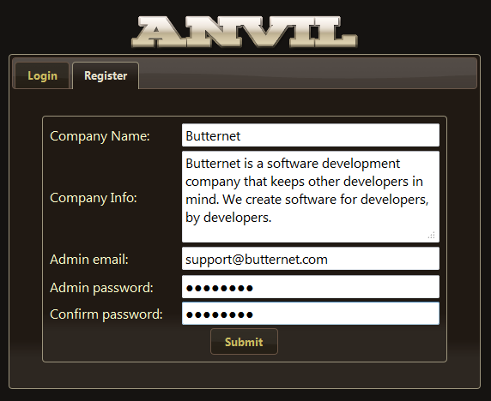

Click on the *Register* tab. Make your decision about the Admin email very carefully, as this cannot be changed. We use this as the reference for your company. If it is essential to change this email it can be done by contacting our support team: [support@butternet.com](mailto:support@butternet.com).

When the Submit button is clicked, an email will be sent to the email address supplied, containing an activation URL. This URL will need to be followed to activate the company that you have just registered. Once your company has been activated, you may log in.

Welcome to Anvil.

# Managing your company’s projects

Before development on a project can begin, you need to add the project into Anvil.

## Project management

Click on the Admin tab to see a list of projects in your company.

### Adding/Editing a Project

To add a project to this list, click on the *Add Project* button. This will bring up the form with details about the project that need to be entered before the project is added. Fill in these details and click *Save*.

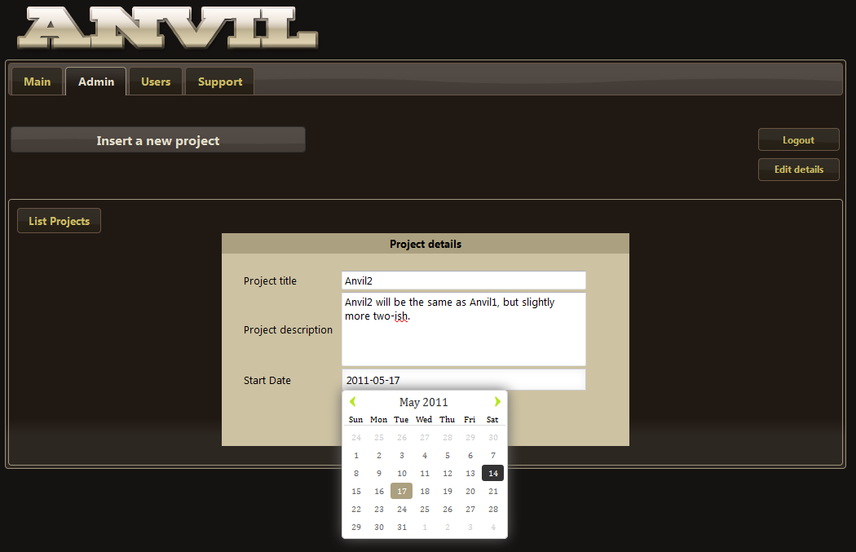

To edit the details of a project at any given time, click on the edit button next to the project in the project list.

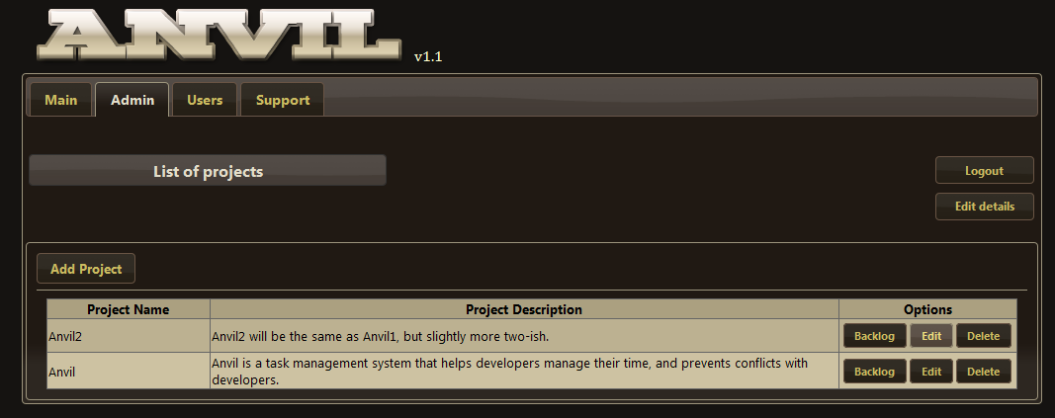

The details are the same as adding a project.

### Deleting Project

To delete a project, click on the *Delete* button next to a project in the list.

**WARNING**: Deleting a project will remove all Features, Releases and Tasks for that project as well. Be careful when deleting a project.

## Project backlog

The Project Backlog can be accessed via the *Backlog* button next to each project in the Project List.

The Backlog Display page shows all releases that are contained in the project. It also shows each feature, and which release the feature belongs to. On this page, there is also a Feature Backlog that shows all features not currently assigned to a release. You can drag and drop features from the Feature Backlog into any release that is contained in this project.

To see more details about each feature, hover the mouse pointer over the feature object. A tooltip will pop up showing the details for the feature.

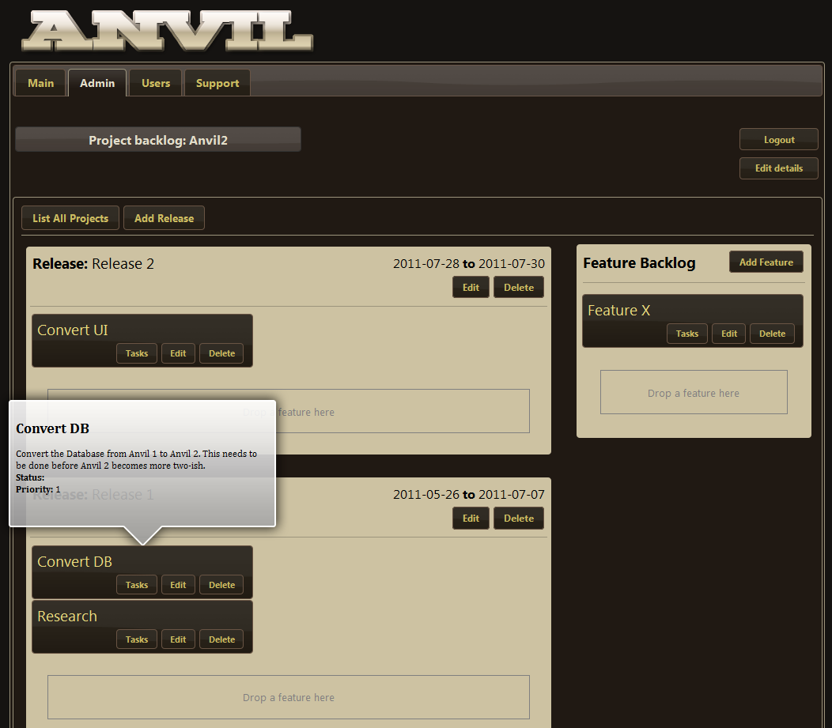

### Manging releases

To add a release to a project, click on the *Add Release* button. Fill in the details of the release and click *Save*.

To edit a release’s details at any given time, click on the *Edit* button on the release object.

To delete a release, click the *Delete* button on the release object. When a release is deleted, all the features that were contained in that release will move back to the Feature Backlog.

### Adding/Editing features

To add a feature, click the *Add Feature* button on the Feature Backlog window. This will load the form to fill in details about the feature that you need to add. Some of the details may be a bit unclear, see the following explanations:

* Feature status – Choice of *Impeded* or Auto *Detect*. This is where you can set the feature status to *Impeded*. When a feature is set to *Impeded*, the tasks cannot be changed on the task board. No tasks can be added by Team Members to this feature from the task board either. When the status is set to *Auto detect*, the feature status is automatically determined from the status of all of its tasks. The feature status will be automatically determined into one of the following:
  + *Not started* – All tasks for the feature are of the *Not Started* status.
  + *In Progress* – One or more tasks are not of the same status.
  + *Done* – All tasks are of the status *Done*.
* Feature priority – The priority of the feature. The features will be ordered inside the release(s) by priority and then by title.  
   it can be one of the following:
  + 5 – Doesn’t matter
  + 4 – Not Important
  + 3 – Slightly Important
  + 2 – Important
  + 1 – Very Important

## Managing tasks for a feature

Tasks can be added to a feature from the backlog page by clicking on the *Tasks* button located inside one of the feature objects. This button will bring up a list of tasks contained inside this feature.

To add tasks to this list, click on the *Add Task* button at the top of the list. When adding a task, it can be assigned to a specific developer who will be doing the task. The developer can assign themselves to a task at any given time to say that they are doing that task. Fill in the details and click *Save* to save the task.

The priority can be adjusted at any given time from this task list by dragging the tasks up and down in the list.

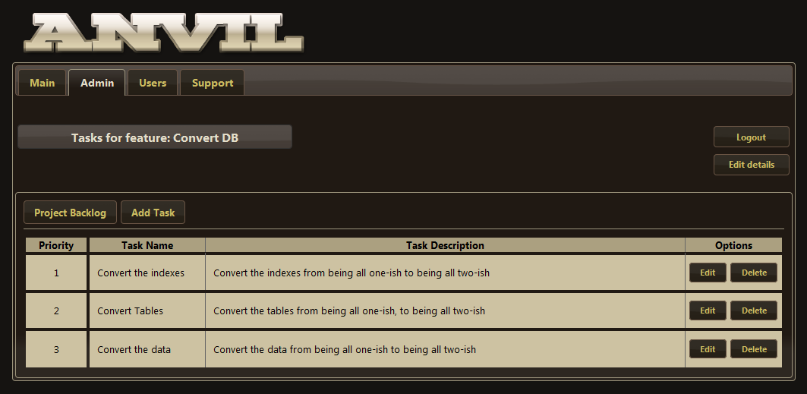

# Managing your companies users

Anvil allows for multiple teams of users to work on different projects. This means that team members will only see and interact with project that their team is allowed to access.

To begin user management click on the *Users* tab. This will show a list of users for your company and which team they belong to.

## Adding a user to your company

To add a user to your company, click on the *Add User* button above the user list. You can choose if they are a team administrator here, by selecting *Administrator: Yes*. Fill in the details and click *Save*.

Once a user has been saved, their email address cannot change. Users can only change their own passwords. This is here for a safety measure, so that the entire user database cannot be destroyed by one person’s negligence.

## Managing teams inside your company

By default there is a Super Team that the Company Admin gets assigned to. This team cannot be edited or deleted. The Super Team has access to all projects in the company. Access your company’s teams by clicking on the *Team Management* button under the *Users* tab.

You can add limited teams that only interact with certain projects by clicking the *Add Team* button.

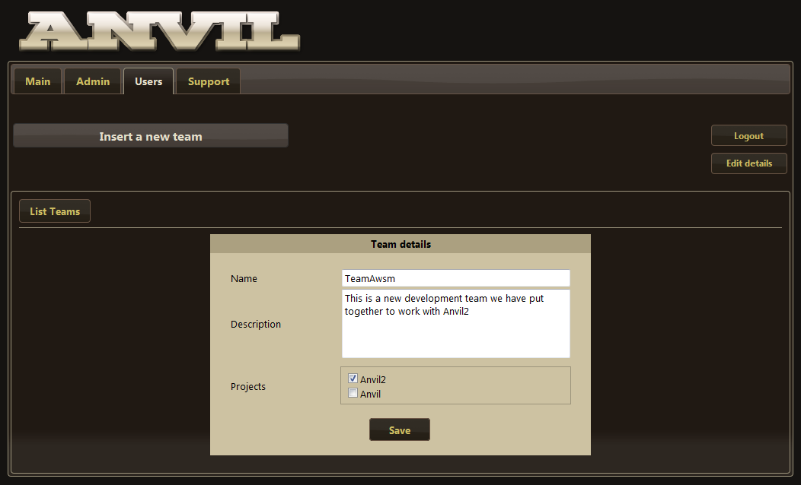

By selecting the projects when adding/editing a team, it limits users belonging to this team to interacting with those projects.

You can delete and edit these teams at any given time via the team list.

**WARNING**: Deleting a team that contains users will mean that all users that belonged to that team will no longer be able to see any projects until they are assigned to a new team.

# Using the taskboard

You could say that the task board is the main feature of Anvil. The task board allows developers to track progress on tasks that need to be done for a specific feature. Many people like to use Post-it notes on a white board to track task progress, but this digital task board is a more modern version of this.

The tasks are spread out across the board in their current status column. They are also ordered by priority, which can be adjusted by the Team Manager or Company Manager using the task list in the *Admin* tab.

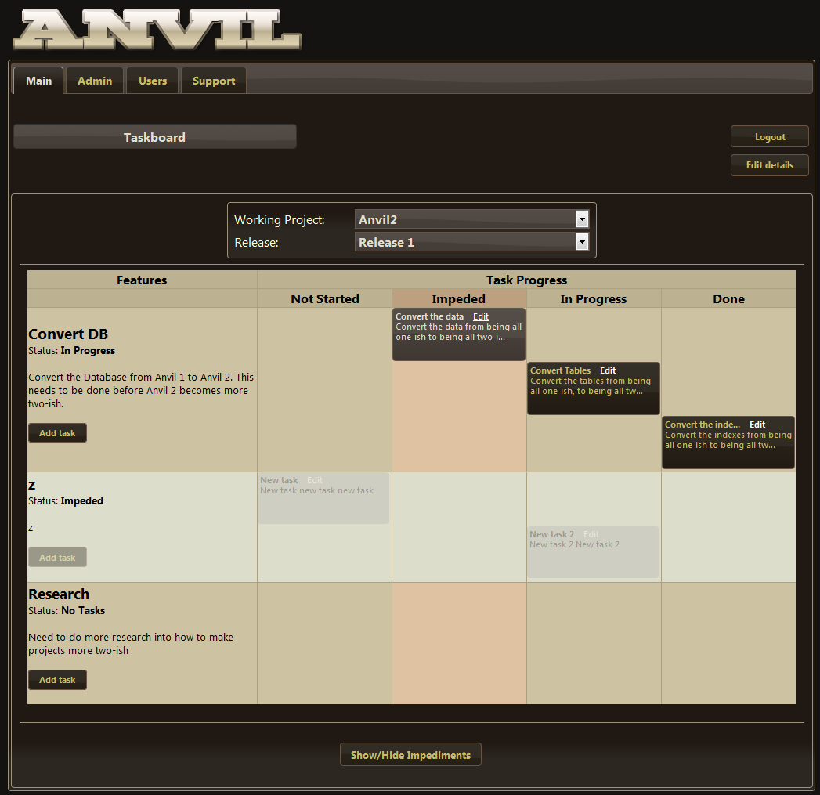

## Selecting Project and release

The “Working Project” and “Release” select boxes are automatically determined using a complicated set of algorithms to try and choose the project and release that your team is currently busy with. You can change the project and release by selecting them from the other options in the list.

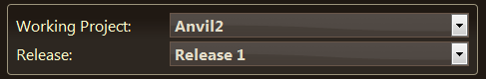

## Drag and dropping tasks

Each task can be dragged and dropped into its new status on the board. Each person viewing this page will get the updates of tasks that are moved on your side. If you have not reloaded the page since someone else has changed the status on a task, a warning will show up, asking if you want to reload the page.

Each task that is assigned to you will be highlighted, and if you hover over the task, it will tell you exactly who is assigned to any of the tasks on the board.

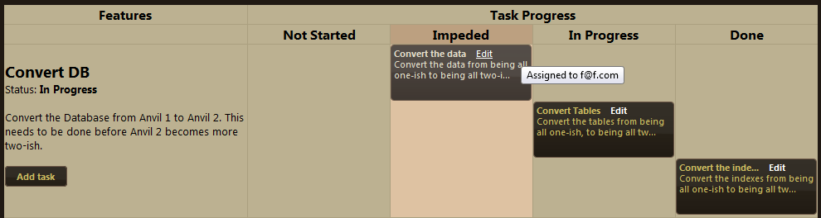

If the feature has been set to *Impeded* by the Company Admin or Team Admin, the tasks cannot be updated, and no tasks can be added from the task board page.

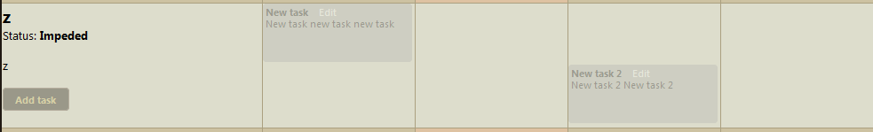

## Adding a task

A task can be added from this page, by clicking on the *Add Task* button contained inside the feature row. The assigned user will be defaulted to you.

## Logout and Edit Details

You can logout of Anvil at any given time by clicking on the *Logout* button.

You can edit your own details at any given time by clicking on the *Edit Details* button.

## Managing impediments

If at any time an impediment pops up that is stopping you from doing your work, it can be added to the Impediments. The team admin should see these impediments and solve them as soon as possible. The impediments can be accessed at the bottom of the task board page by clicking on the *Show/Hide impediments* button.

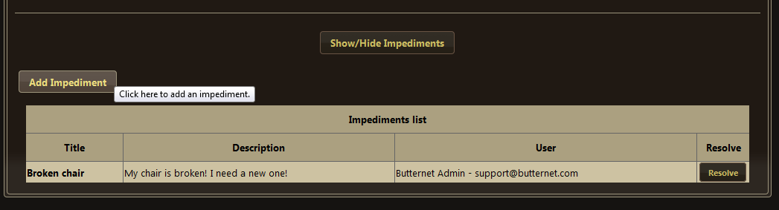

# Using Anvil Support

Anvil prides itself on their customer support. If anything appears to be a bit buggy, or something serious has gone wrong, let us know. Before sending an email to [support@butternet.com](mailto:support@butternet.com), take a look at our support features in the program.

## User documentation

The user documentation for all roles can be downloaded from the *Support* tab, under the sub-tab: *User documentation*. Just by clicking on the PDF Icon of an item in the list, you can download the latest version of the documentation.

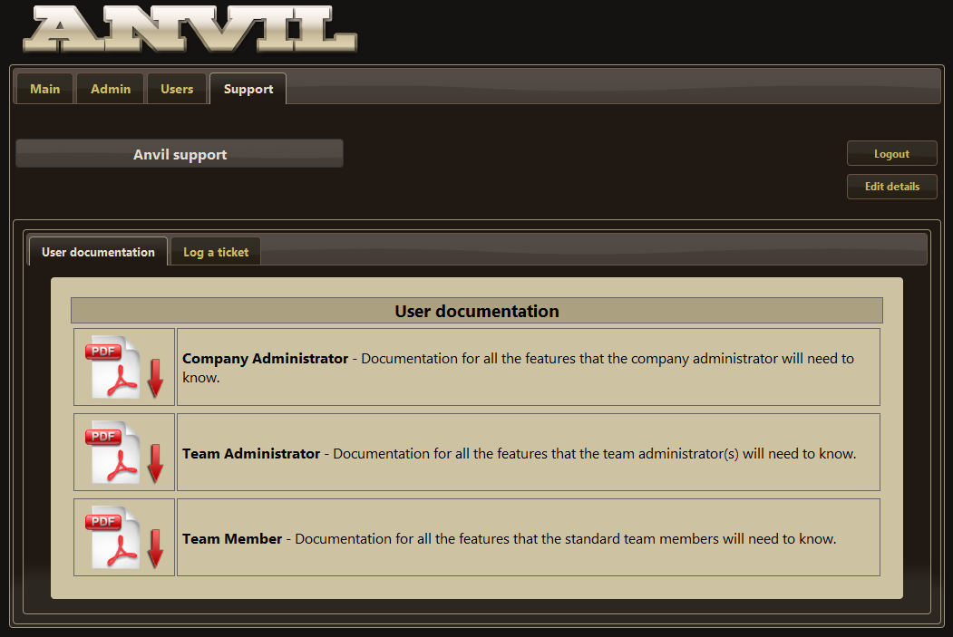

## Logging a ticket

If something is wrong with Anvil, you may log a ticket with our support team. This can be accessed via the *Support* tab, then clicking on the *Log a ticket* sub-tab.

See the following screenshot for an example:  
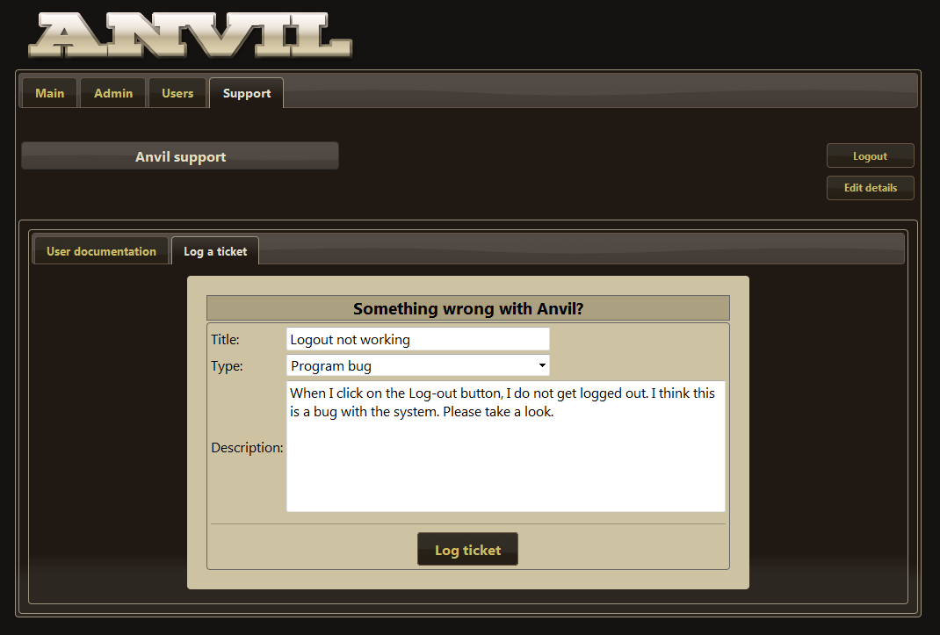

When you have finished filling in your problem, click on the *Log ticket* button. This will send an email to the Anvil Support team. It will also send an auto-respond email to you.

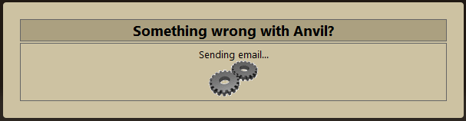

Please do not close the browser or navigate away from the page while it is telling you that the email is sending.